The 11th Tyler’s Hope Foundation Think Tank
Recent Advances and Future Directions for
DYT-TOR1A dystonia

Tuesday, November 17th, 2020

Virtual Hub: Norman Fixel Institute for Neurological Diseases, 3009 Williston Road

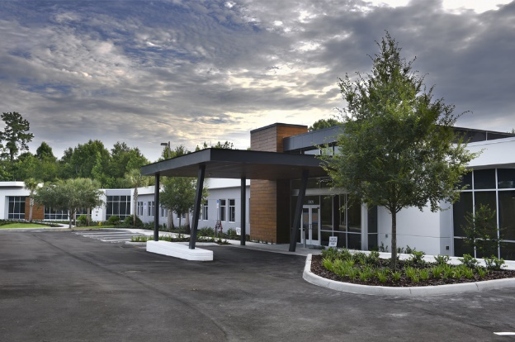

9 – 9:10 am Welcome and Introduction

Session 1:
Understanding the dystonia gene
Session Chair: Matthew Farrer
Discussants: Drs. Laurie Ozelius, Chris Bragg

9:10 – 9:30 am Mutant Allele-Specific CRISPR Disruption in DYT1 Dystonia Fibroblasts Restores Cell Function
Dr. Xandra O Breakefield

9:30 – 9:50 am Dystonia genes functionally converge in specific neurons and share neurobiology with psychiatric disorders
Dr. Niccolo Mencacci

9:50 – 10:00 am Discussion

10:00 – 10:10 am Coffee Break (15 minutes)

Session 2:
Torsin protein and biochemical pathways: Lessons learnt from the mouse model
Session Chair: Dr. Mark Moehle
Discussants: Drs. David Standaert, Nicole Calakos

10:10 – 10:30 am Torsin B overexpression prevents abnormal twisting in DYT1 dystonia mouse models
Dr. W Dauer

10:30 – 10:50 am Improved survival and overt "dystonic" symptoms in a torsinA hypofunction mouse model.
Dr. Yuqing Li

10:50 – 11:10 am Striatal cell type-specific transcriptional profile in a GNAL dystonia mouse model indicates new avenues for dystonia research
Dr. Karen Jaunarajs

11:10 – 11:30 am Cell-Specific Effects of Dyt1 Knock-out on Sensory Processing, Network-Level Connectivity, and Motor Deficits
Dr. Bradley Wilkes

11:30 – 12:30 pm Discussion

12:30 – 13:00 pm Lunch break (30 minutes)

Session 3:
Imaging, Physiology, and treatment
Session Chair: Aparna Wagle Shukla
Discussants: Drs. Hyder Jinnah, Nutan Sharma, Mark Hallett

13:00 – 13:20 pm A microstructural neural network biomarker for dystonia diagnosis identified by a DystoniaNet deep learning platform.
Dr. Kristina Simonyan

13:20 – 13:40 pm Electrophysiology and dystonia
Dr. Cora de Hemptinne

13:40 – 14:00 pm M4 selective antagonists for the treatment of dystonia
Dr. Mark Moehle

13:30 – 13:50 pm Gene-based therapy approaches
Dr. Edgar Rodriguez-Lebron

13:50 – 14:10 pm Emerging role of Biotechnology
Dr. Brian Price

14:10 – 15:00 Discussion and wrap up

